February 28, 2024
Ref: IIH/MD/2024/02/003
The GMD/CEO,
Harmony Holdings Ltd,
Ibrahim Taiwo Road,
Ilorin, Kwara State.
Dear Sir,
RE: REQUEST TO OBTAIN ILORIN INNOVATION HUB REGISTRATION DOCUMENTS
The company Ilorin Innovation Hub Ltd (RC number 1664691) was registered in 2020 by Harmony Holdings as part of an initial arrangement for the establishment of the Ilorin Innovation Hub until a subsequent decision was made to move the company from Harmony Holdings to sole ownership by the Kwara State Government (via it’s representatives).
As a follow-up to the approval given by His Excellency Abdulrahman Abdulrazaq to effect this change of ownership, I would like to ask for the Corporate Affairs Commission (CAC) registration documents to be handed over so the Ilorin Innovation Hub so as to start the process of company reactivation and effecting the change of directors on the private limited company.
Attached is an approval from His Excellency to this effect, and I will look forward to hearing back from you soon. Please note that
Thank you for your continued cooperation.
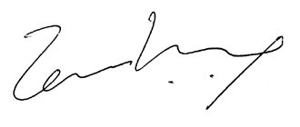

Temi Kolawole
ag. MD Ilorin Innovation Hub

